August 10, 2016

Adhesion to Stainless Steel Roof Panels

Sample Preparation

Two stainless steel corrugated roof sample specimens were provided for adhesion testing. The coating process is outlined in the document ‘Internal Traveller SS#1’ as follows;

Sample #1
- Degrease with 3901S
- 36 grit sanding
- Clean with 3901S
- Metalok 235S
- Precidium 2200
- Precidium MTI Rail Membrane
- Precidium 1150D RAL 7040 Grey

Sample #2
- Alstom cleaning
- Clean with 3901S
- Metalok 235S
- Precidium 2200
- Precidium MTI Rail Membrane
- Precidium 1150D RAL 7040 Grey

Due to the dimensions of the corrugation of the panel and the test fixture, dollies could only be applied to the smaller upper ridges, which are slightly narrower than the dollies. Every effort was made to center the dollies as much as possible and keep them on the flattest areas. An attempt was made on panel 1-2 to cut the coating to the substrate and then flatten the panel to attach dollies to the wider bottom areas, but this did not prove feasible to do for all of the samples and was destructive to the integrity of the panel.

Test Method
The ASTM D4541-09 test method is a procedure for evaluating the pull-off strength (adhesion) of a coating from metal substrates, or other rigid substrates such as plastic and wood, using a portable pull-off adhesion tester. Test Method E – Self Aligning Adhesion Tester Type V was followed.

In order to ensure adhesion of the test dollies, both the coating surface and bottoms of the dollies were scuffed with a ScotchBrite Type A – Very Fine pad and solvent wiped with MEK. Loctite Hysol E-20HP Epoxy Adhesive was used to attach the dollies. After allowing the epoxy to cure overnight, the dollies were scored around down to the substrate using a circular hole saw on a drill press. A PosiTest AT-CM pull-off adhesion tester was then used to pull the dollies until failure.

Conditions during the test were 23°C and 60% Relative Humidity.

Results
All dollies pulled on all panels resulted in either failure of the adhesive to the dolly, or cohesive failure of the membrane. Values ranged from 600-1000 psi for the adhesive failures and 800-1000 psi for the cohesive failures.

Conclusions
All of the methods tested resulted in favorable results, with the adhesion of the system to the roof panel exceeding the cohesive strength of the membrane. However, due to this the testing does not show any differentiation between the different preparation methods. Testing just the pretreatments/primer combinations would give a better idea of the true adhesion values to the substrate.

From the basis of prior results from other such tests, mechanical abrasion of stainless steel is usually essential to obtaining a good and consistent bond, and as such would be recommended. As well, the use of Metalok 235S has been seen to increase both pull-off and peel adhesion.

Pictures

Figure 1: Test panel 1 after completion of adhesion testing

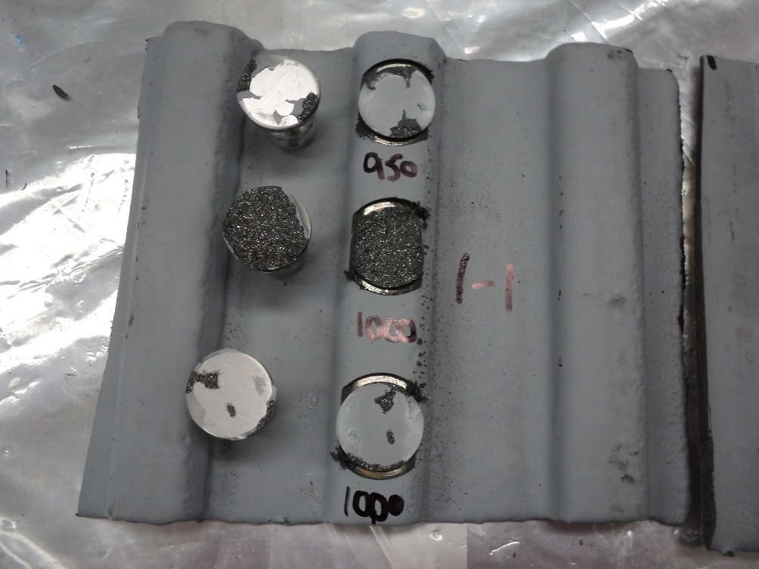
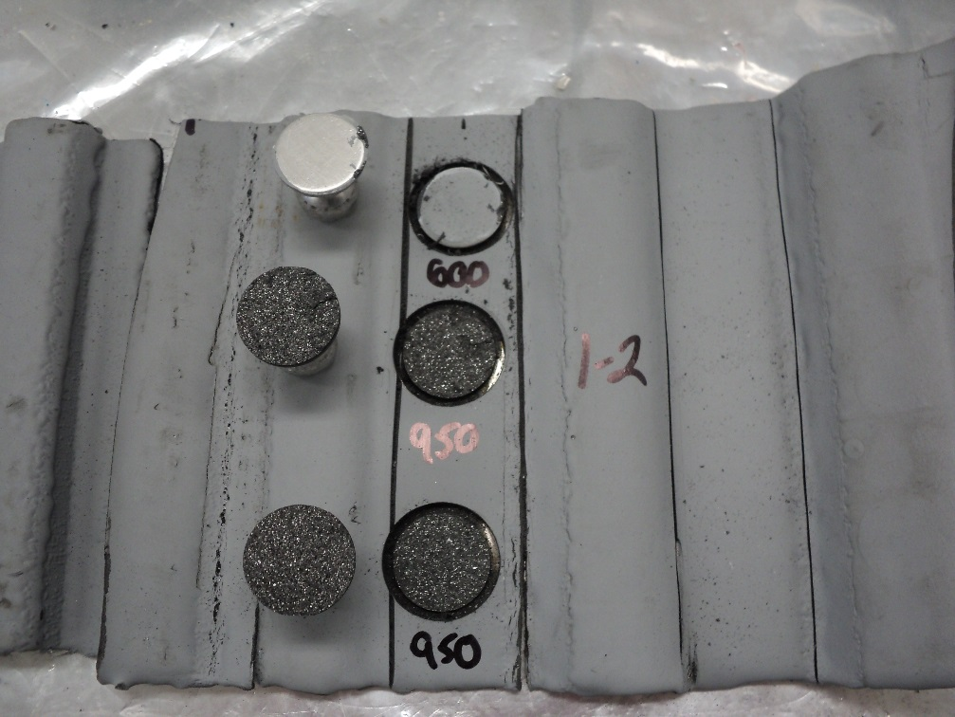

Figure 2: Test panel 2 after completion of adhesion testing

